Decision tree model

With crime data

Cluster 1 binary split

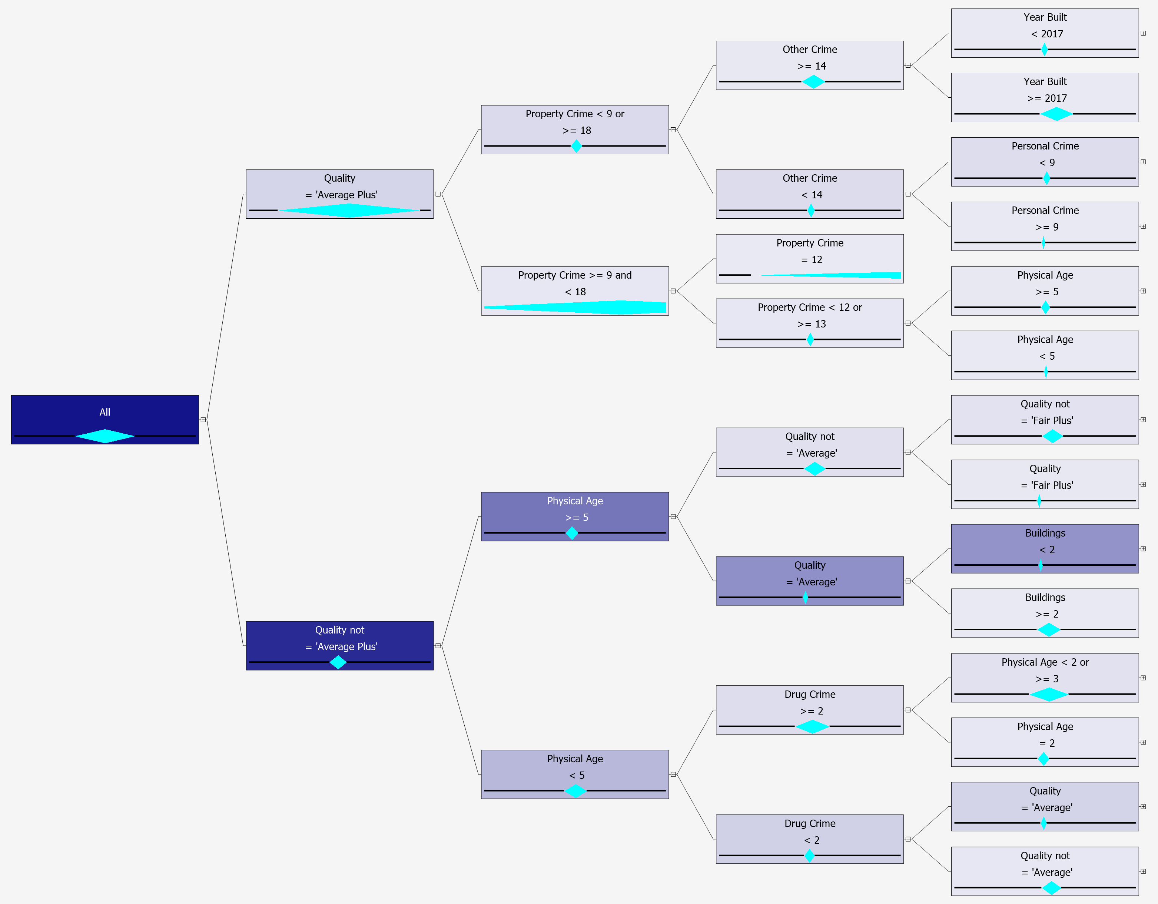

Cluster 1 combine split

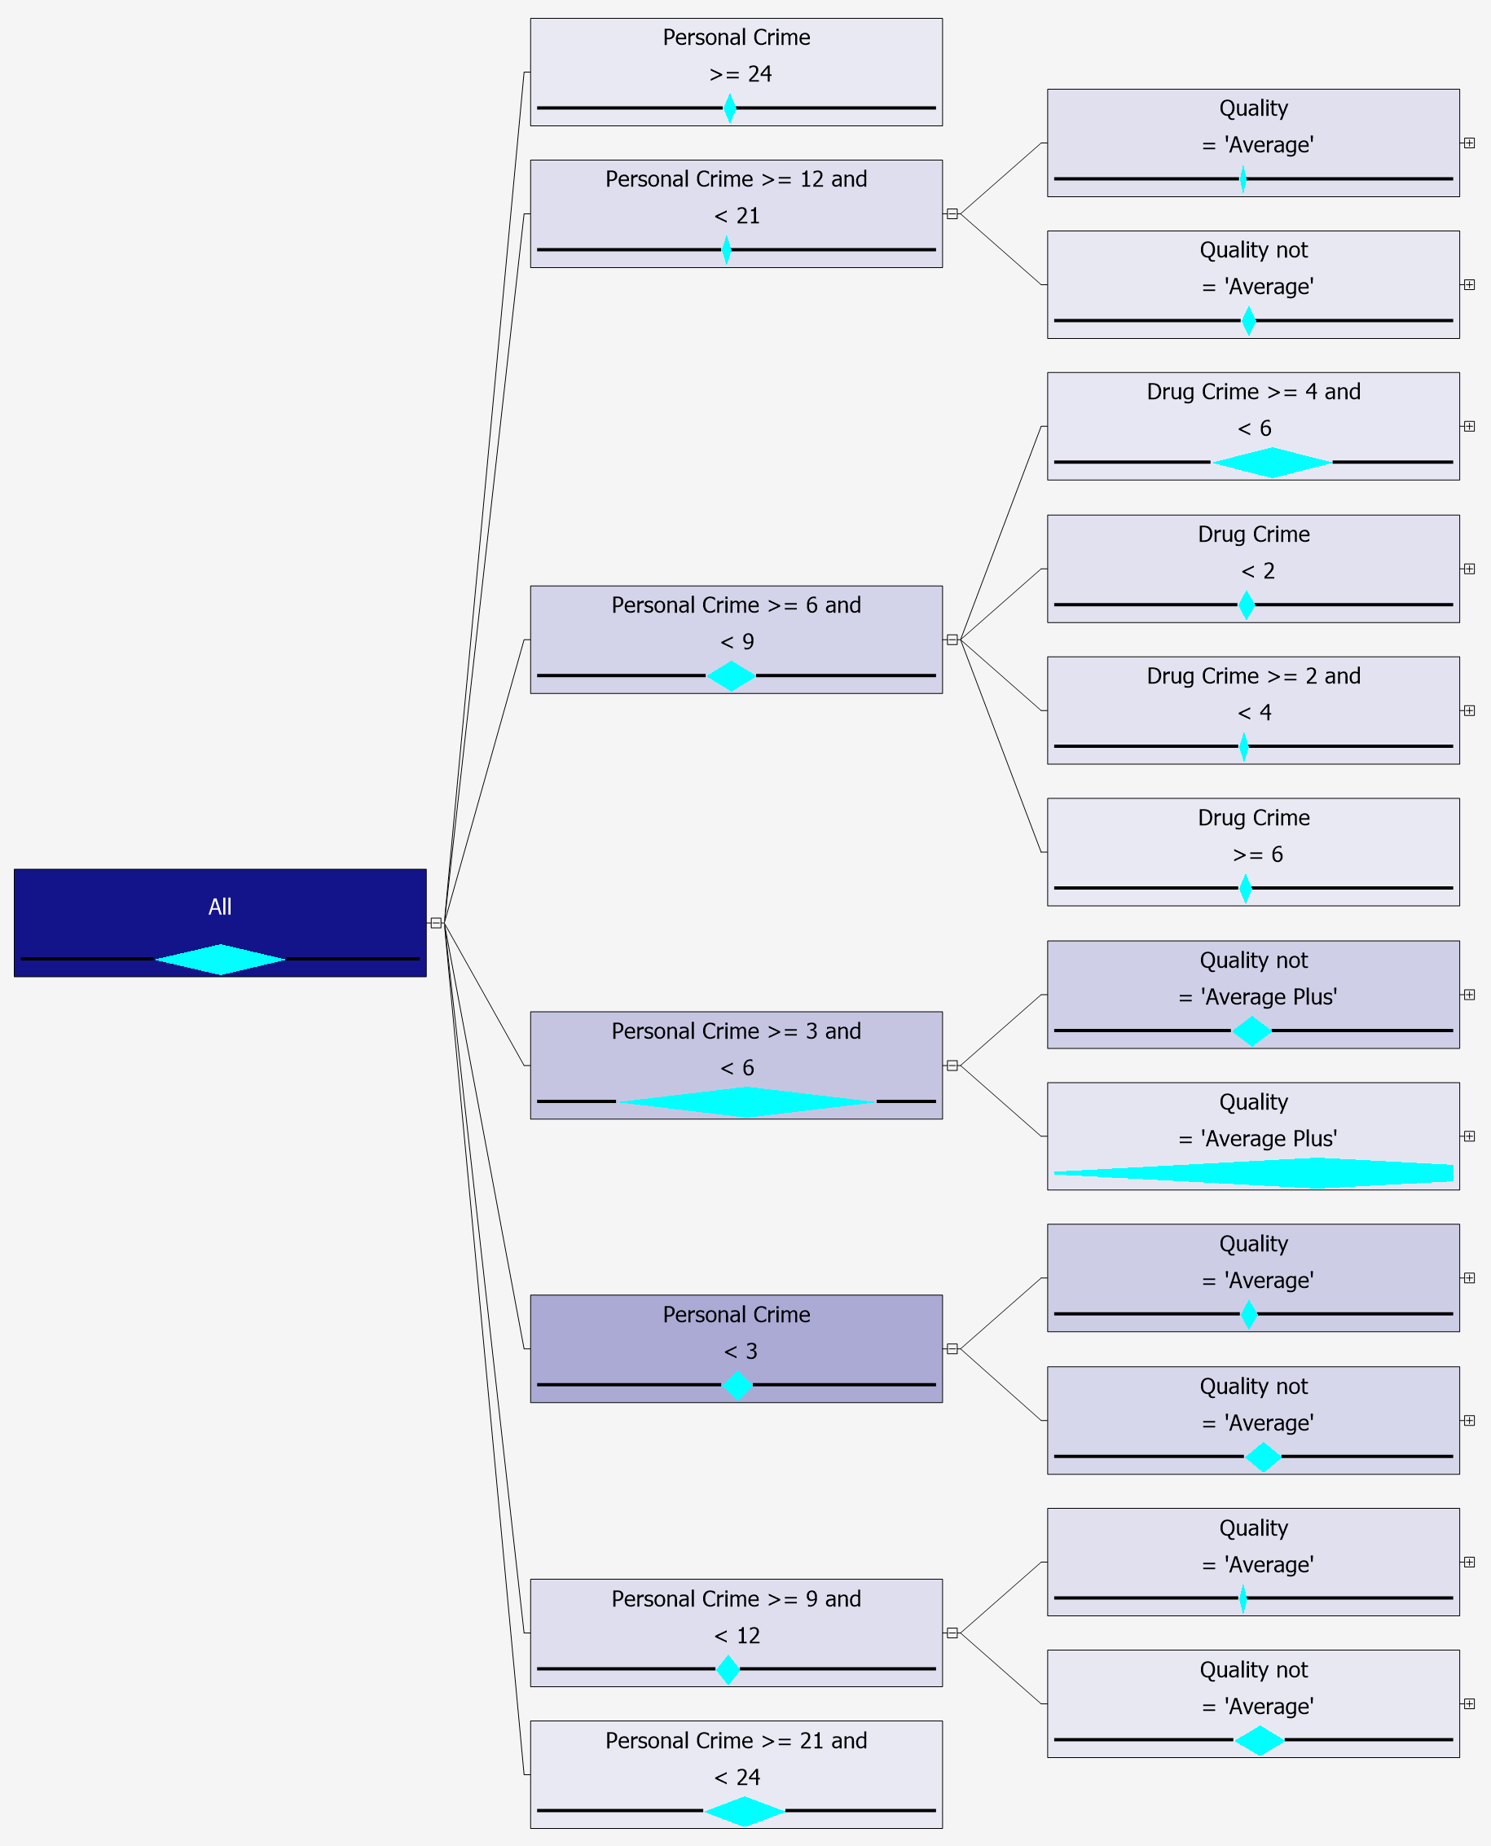

Cluster 2 binary split

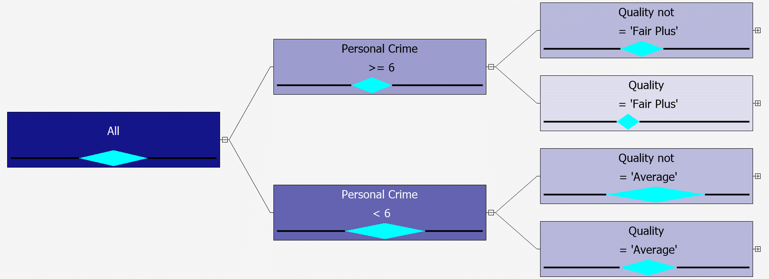

Cluster 2 combine split

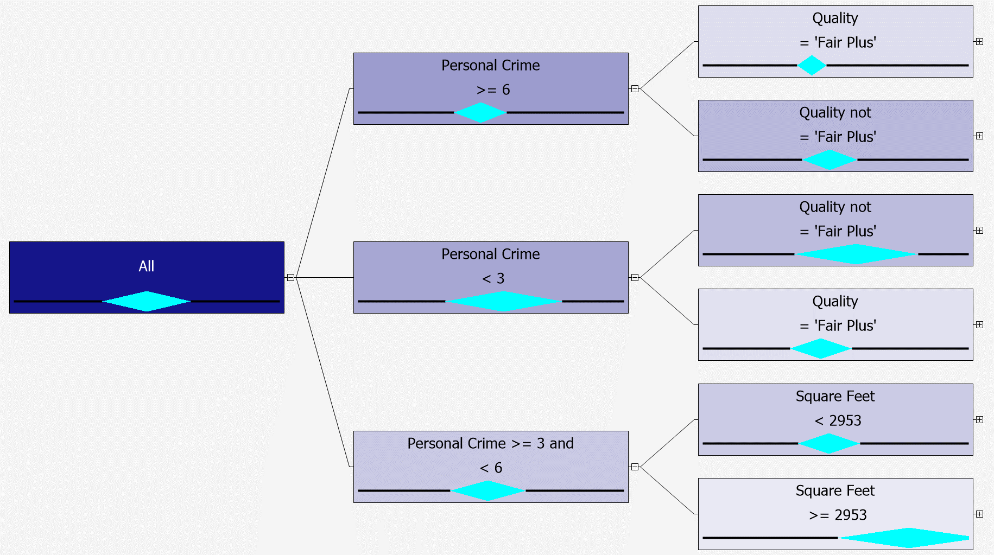

Cluster 3 binary split

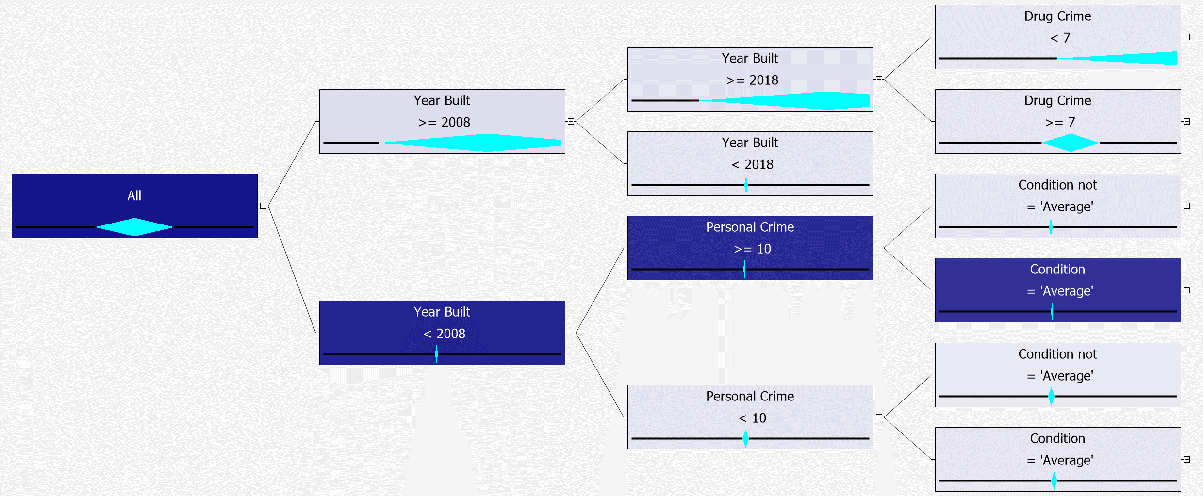

Cluster 3 combine split

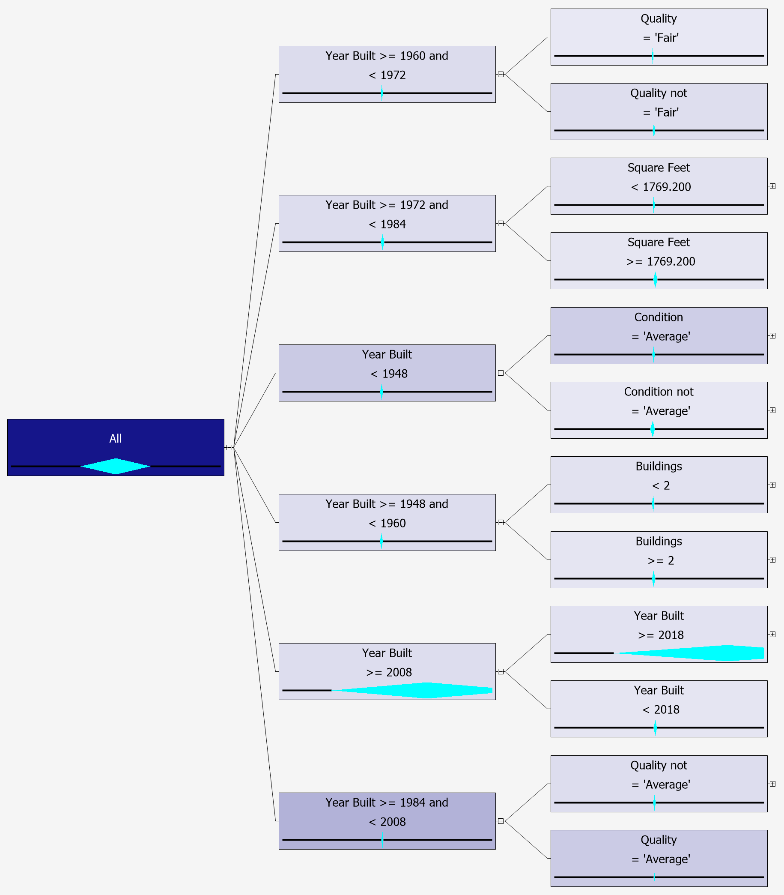

Decision tree model

Without crime data

Cluster 1 binary split

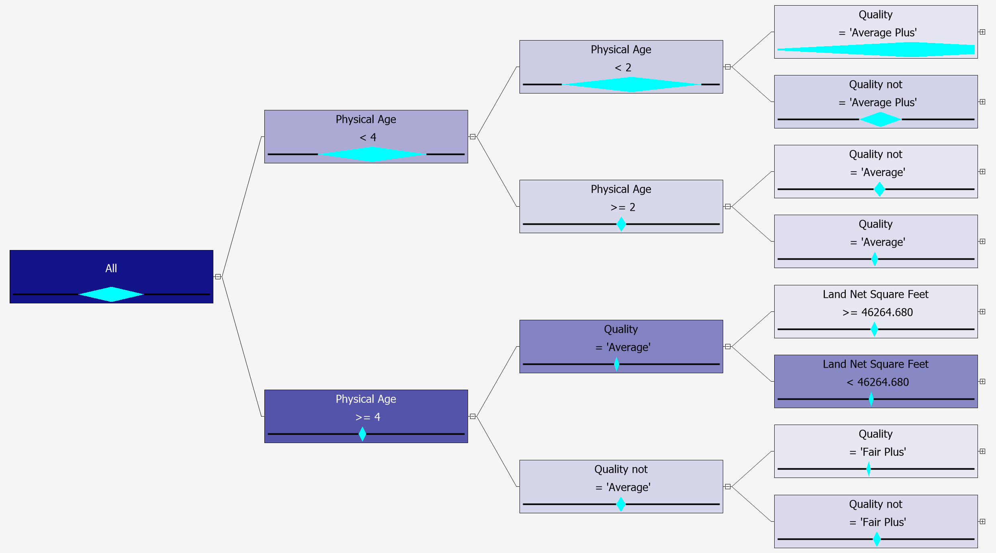

Cluster 1 combine split

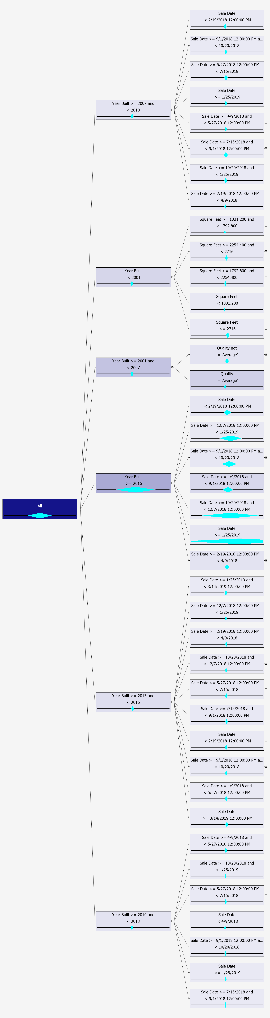

Cluster 2 binary split

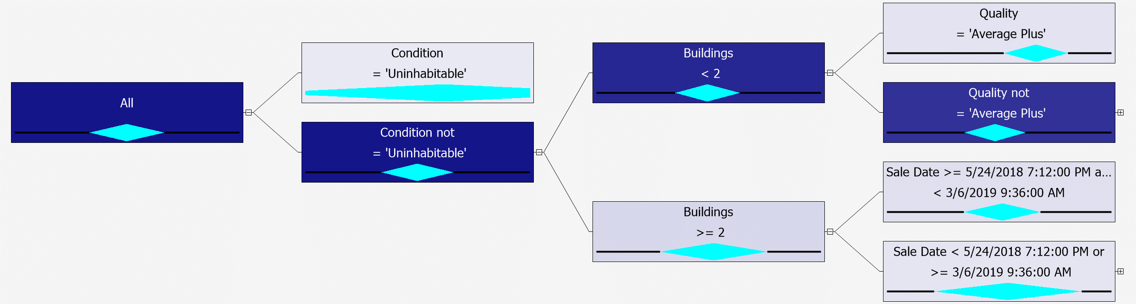

Cluster 2 combine split

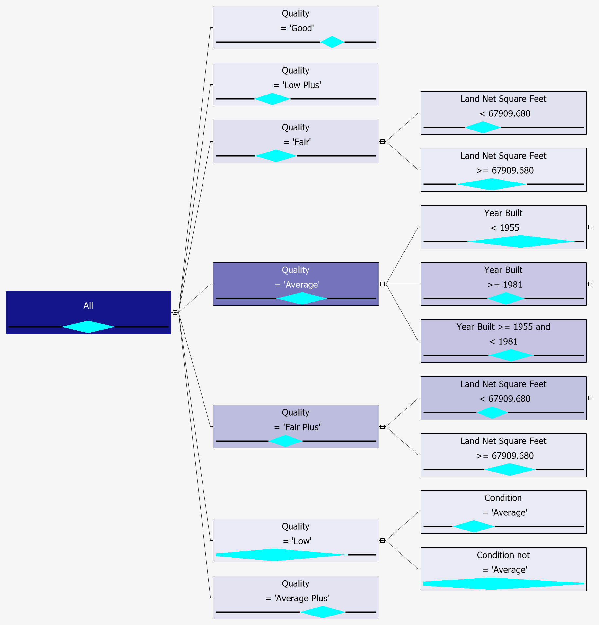

Cluster 3 binary split

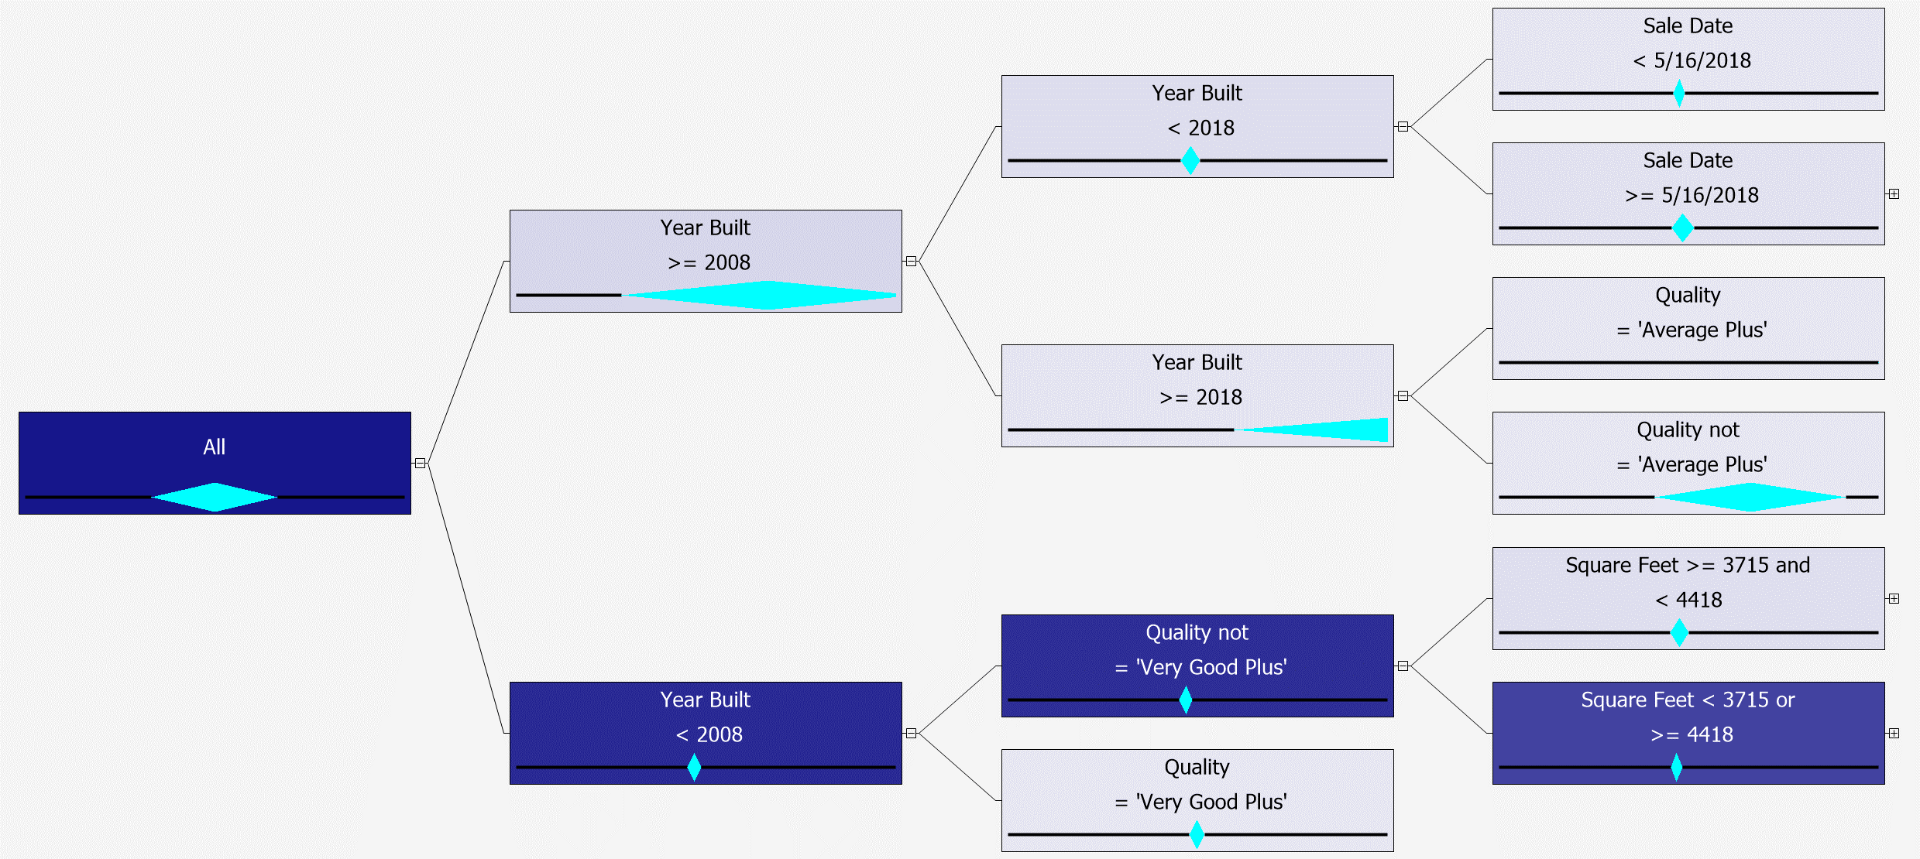

Cluster 3 combine split

